**ASSIGNMENT – 02 supplier assignment**

1. Display all suppliers who statys in state either in california or Texas or Arkansas

Answer :: **select * from suppliers where state in(‘California’,’Texas’,’Arkansas’);**

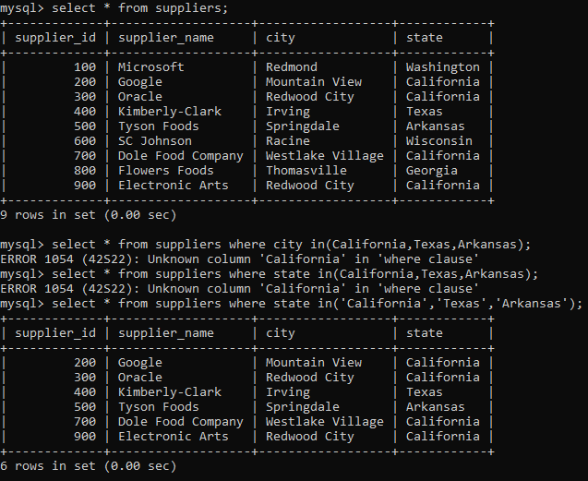

2. list all suppliers who does not stay in Springdale

Answer :: **select * from suppliers where city != ‘springdale’;**

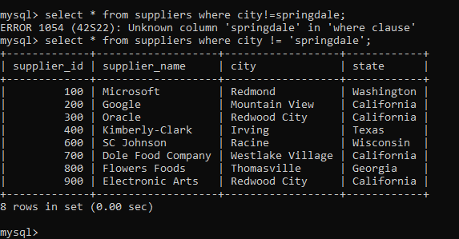

3. find orderid and customerid for orders place on date 18-feb-16

Answer :: **select * from orders where order_date=’2016-02-18’;**

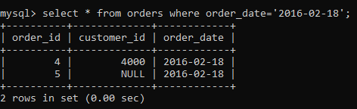

4. find orderid and customerid for orders place on feb 2016

Answer :: **select * from orders where order_date between ‘2016-02-01’ and ‘2016-02-29’;**

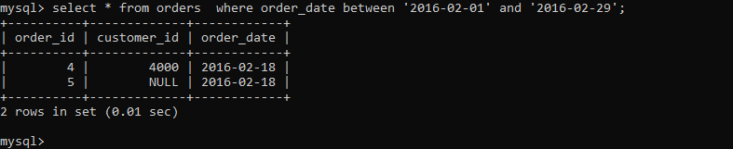

5. find all customers with name 'Reynolds', or Anderson

Answer :: **select * from customers where last_name = ‘Reynolds’ or ‘ Anderson’;**

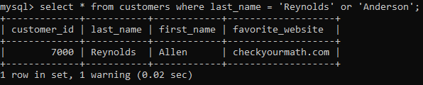

6. find all suppliers with supplierid >=200 and <=700

Answer :: **select * from suppliers where supplier_id between 200 and 700;**

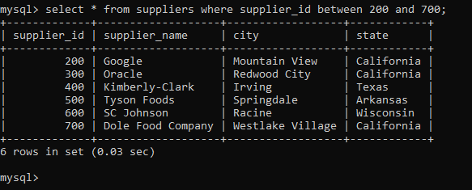

7. find all customers for whome favorite_website is not given

Answer :: **select * from customers where favorite_website is null;**

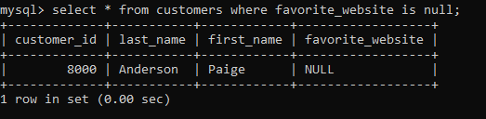

8. find all customers for whome favorite_website is given

Answer :: **select * from customers where favorite_website is not null;**

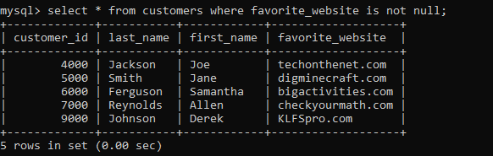

9. find all suppliers with supplierid not >=200 and not <=700

Answer :: **select * from suppliers where supplier_id not between 200 and 700;**

